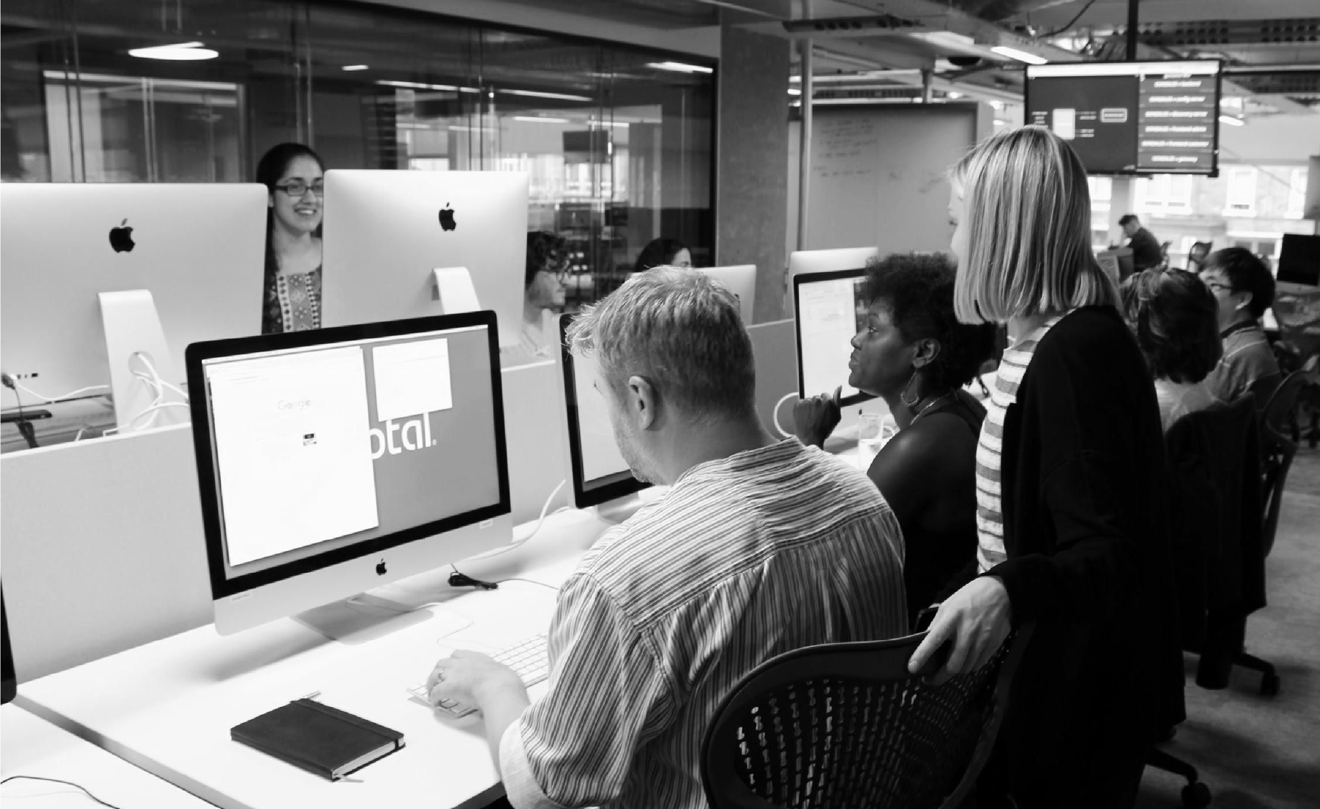

© Copyright 2018 Pivotal Software, Inc. All rights Reserved. Version 1.0

**Migrating Your Apps to the Cloud:**

**How to Do It & What to Avoid**

Tom Collings, Advisory Solutions Architect, Pivotal Application Transformation (AppTx)

Allison Williams, Senior Solutions Architect, Pivotal AppTx



**INTRODUCTIONS**



**Allison Williams**

**Program Lead, Federal**

**Tom Collings**

**Advisory Solutions**

**Architect, Anchor**



# Methodology and Techniques



•

Portfolio level

goals definition

•

Cloud suitability

assessment and

education

•

Define OKRs

•

Discuss timeline,

staffing, risk,

dependencies,

etc.

•

One-week iterations

•

Hands-on code within 2-3 days

•

1

s to 10s of apps moved in 1s of

weeks

•

Working code used to inform a

cookbook of patterns

Product Backlog

)

Pivotal Tracker

(



Boris

Event

Storming

OKRs

Slice

Analysis

Snap /

SnapE

Patterns

**Scoping**

**Discovery**

**Ongoing Delivery Cycle**

We deliver working code via

replatformed apps and modernized

slices that prove out patterns

Value

Stream

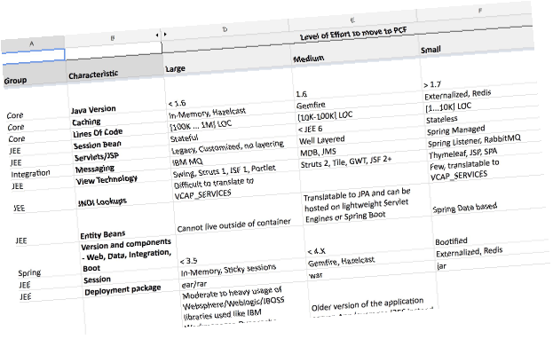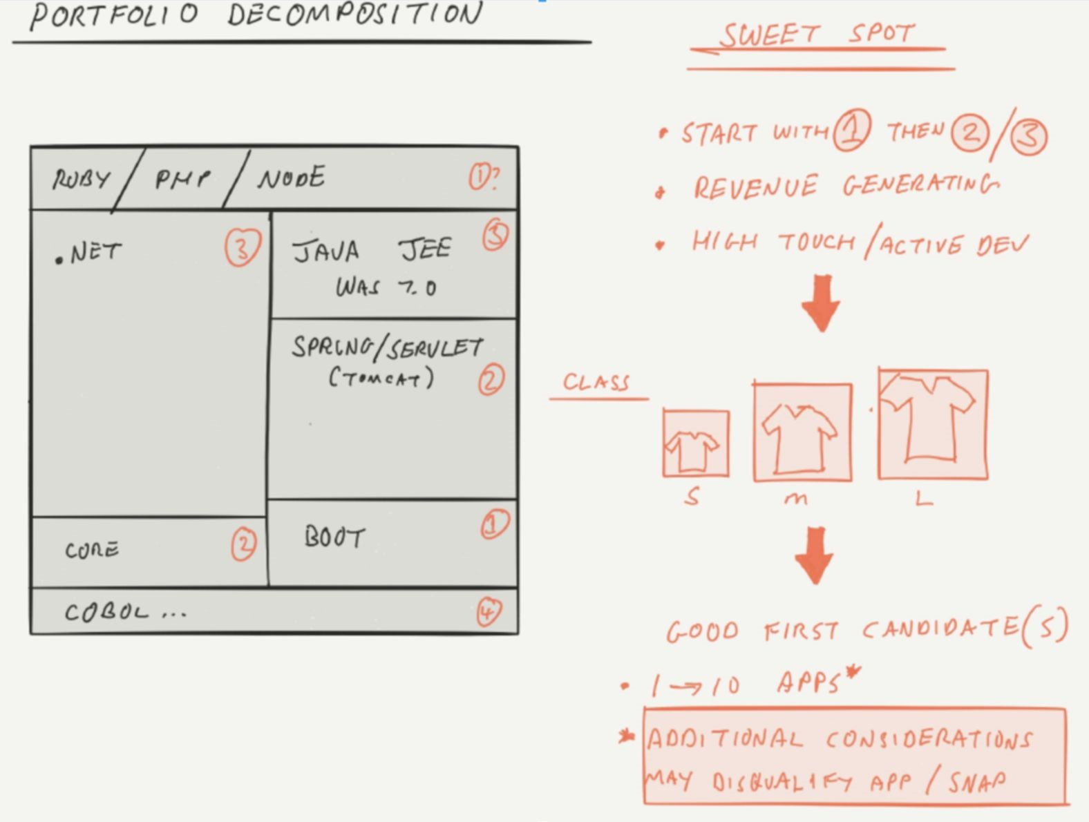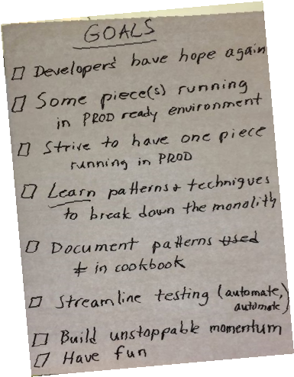

We work on a fixed timeline and

spin this wheel many times, using

the techniques as necessary

**Fixed Timeline Engagement**

**Supported by a Paired Team**

**Our Service Offerings**

**Re-Factor or Re-Build**

Prioritized, paired efforts focused on conversion of existing

systems to cloud native application architectures. Often the

work takes more time to complete but delivers significant

business outcomes.

**Architecture Navigator**

A short, tactical service designed to solve problems (ex. A

performance bottleneck within a cloud native application)

and/or plan a solution (ex. Establish a path forward to

modernize a complex “system of systems”).

**Re-Host or Re-Platform**

Targets mostly “self contained” applications deemed

suitable for PCF or PKS. Focus on path-to-prod and

maximizing the number of apps moved over and as far into

prod as possible. Delivers IT outcomes.

**Program Delivery**

Mix of projects delivered over a longer time horizon by a mix of Pivotal and ecosystem partners. Scoped as a “journey” that gets started

quickly and ramps responsibly based on feedback and measured outcomes. Typically dovetails into partner-led delivery at the right time

as Pivotal shifts into an oversight and coaching role.

**Journey Navigator**

Baseline the path-to-production and lay initial groundwork

for CI/CD automation. Define app migration funnel criteria

and run using a set of apps from the portfolio. Deliver plan of

tactical actions and strategic recommendations.



**TECH**



**BIZ**



**TECH**



**BIZ**

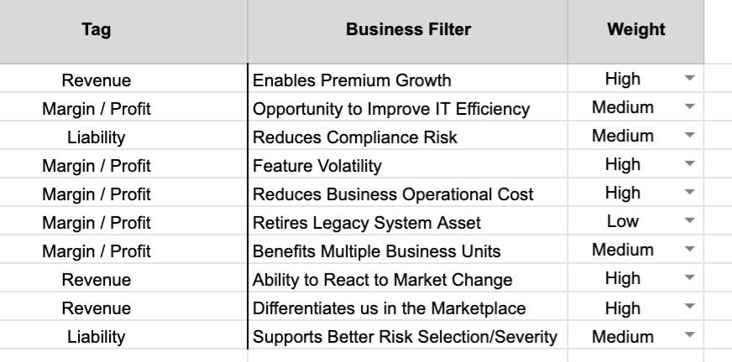

**TECH**



**BIZ**

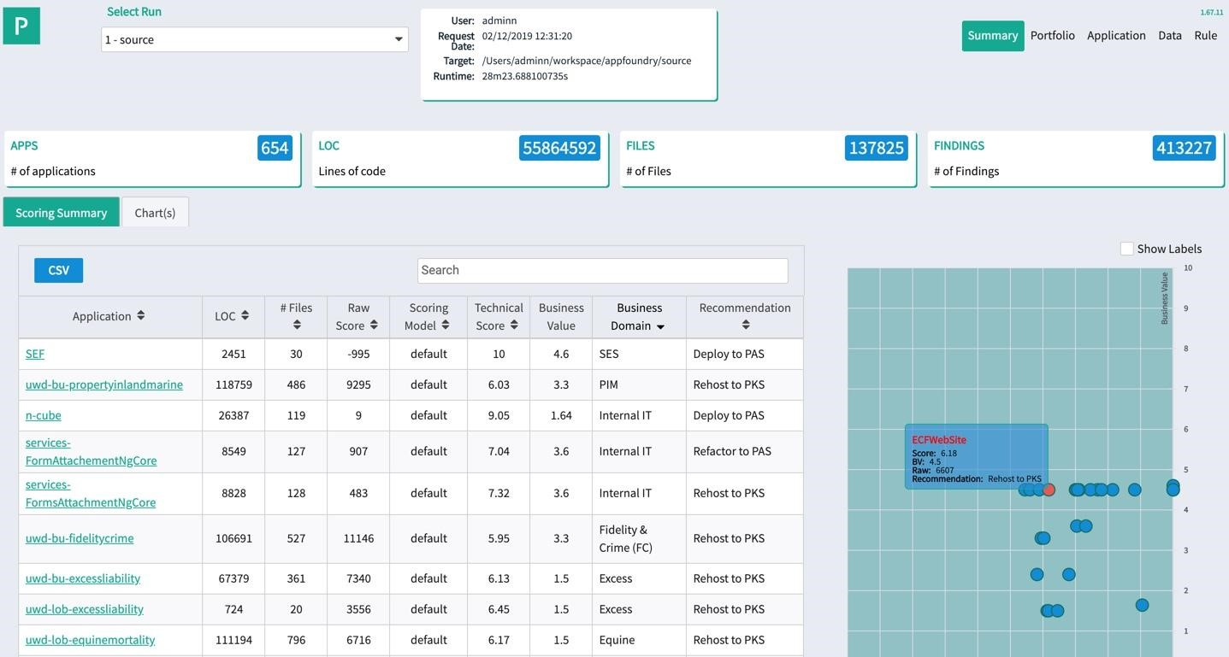

**TECH**



**BIZ**

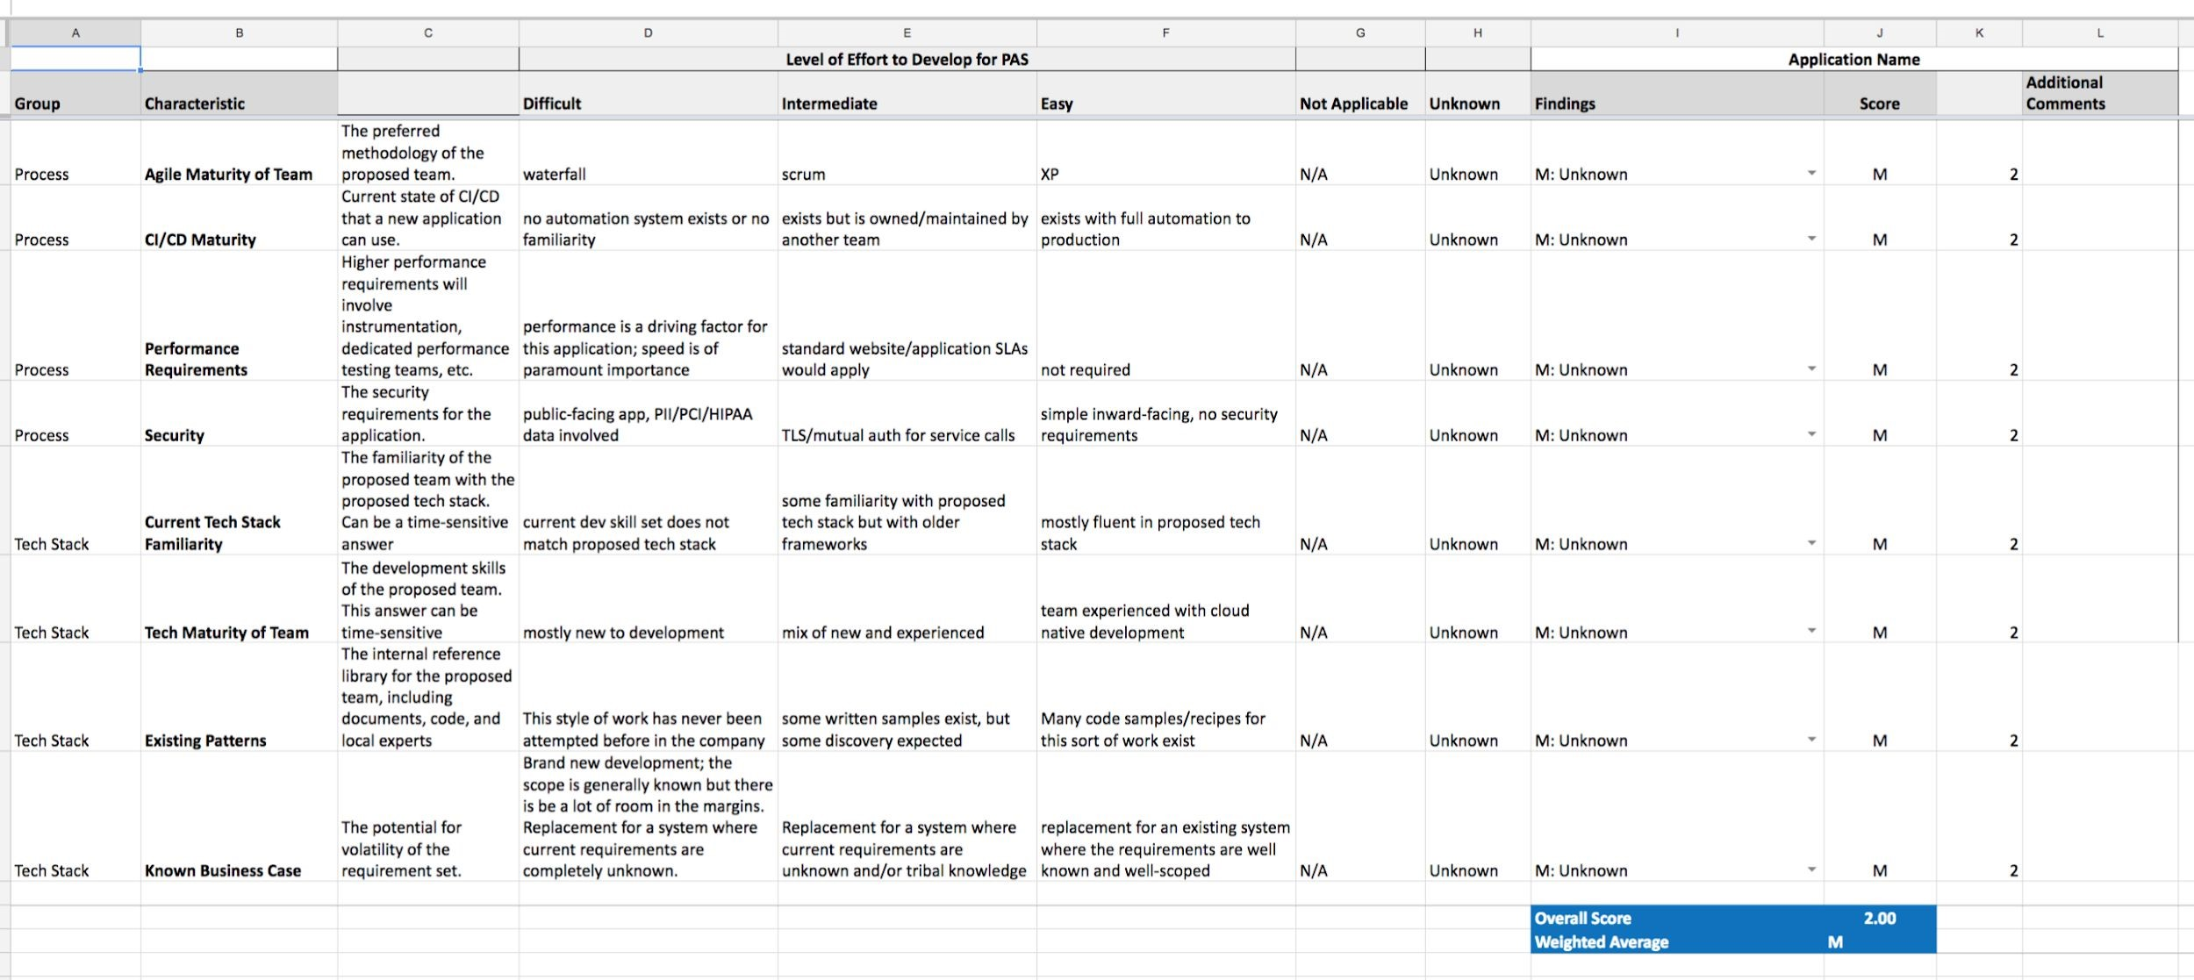

**TECH**



**BIZ**

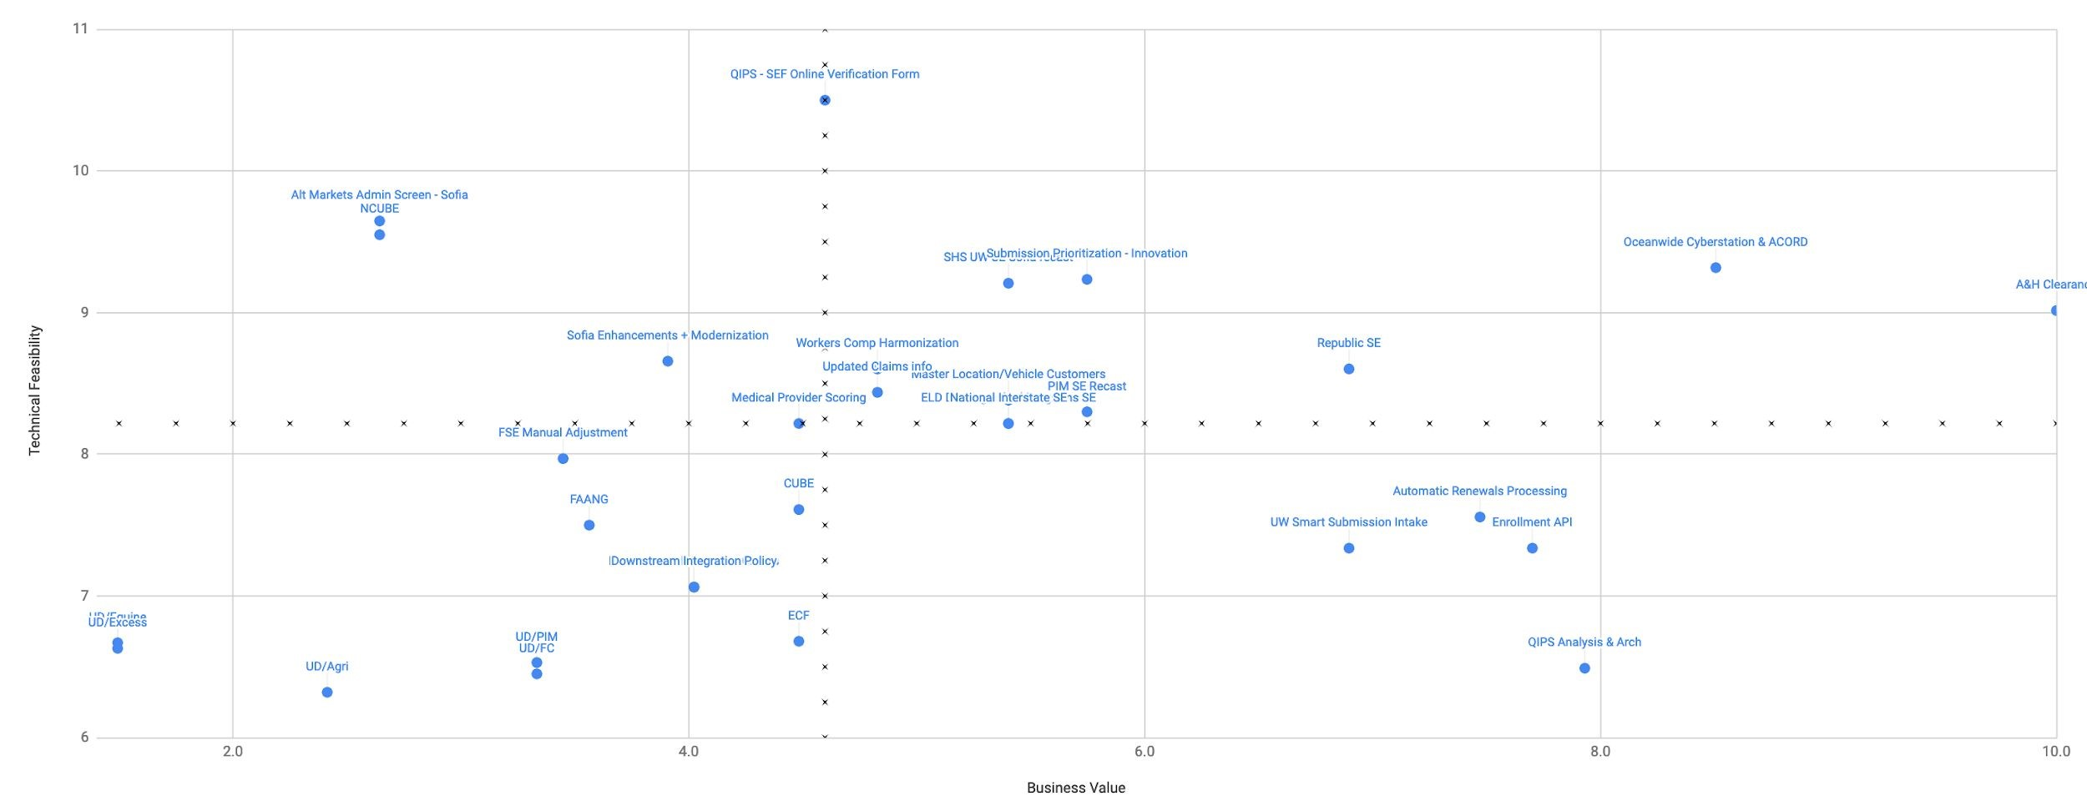

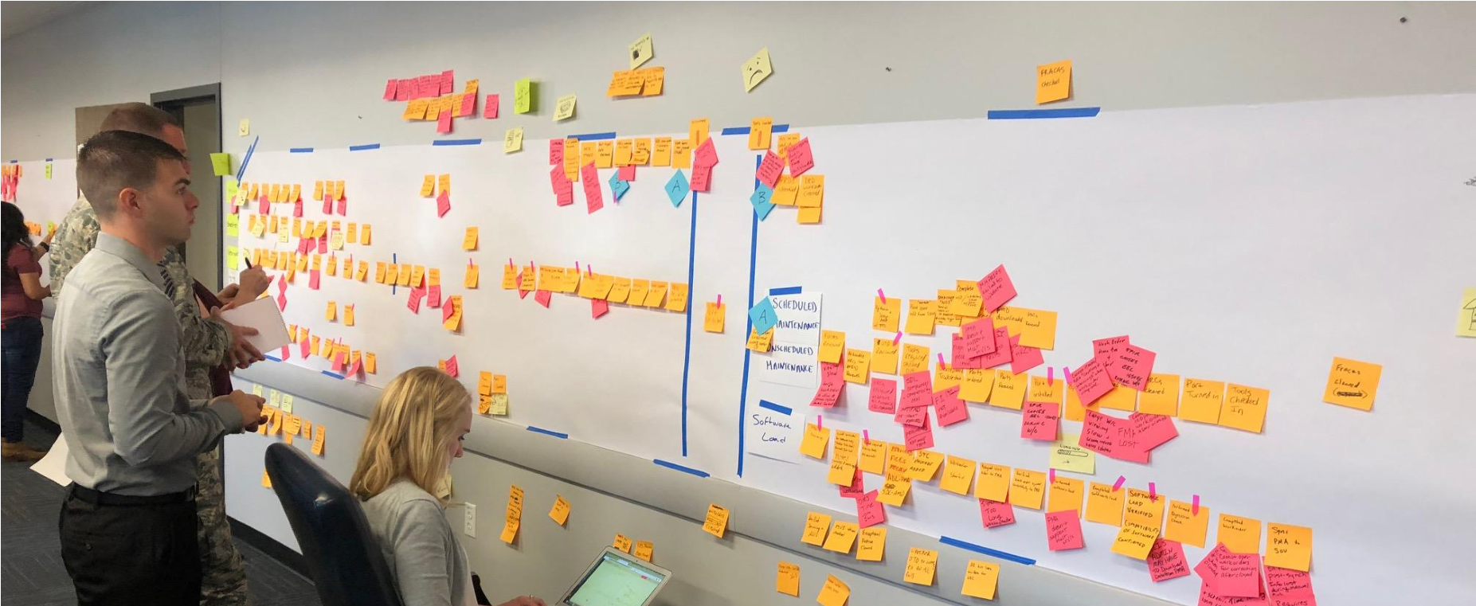

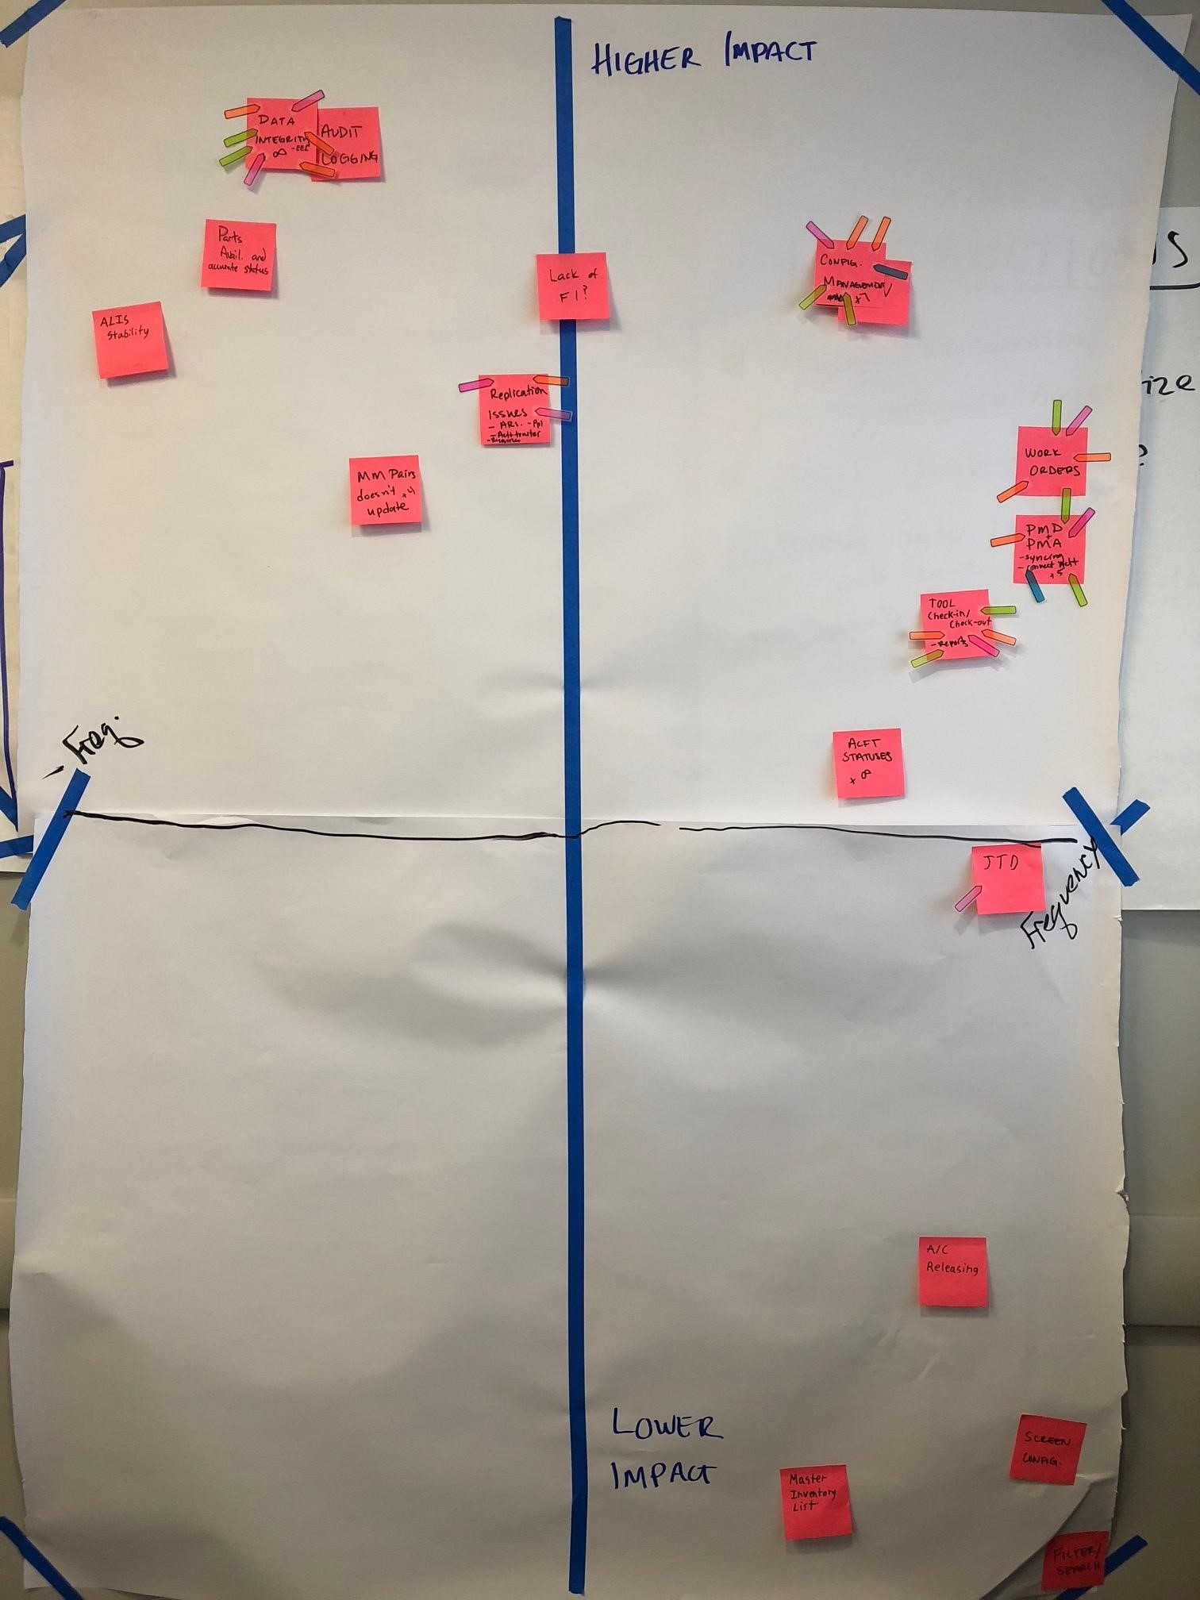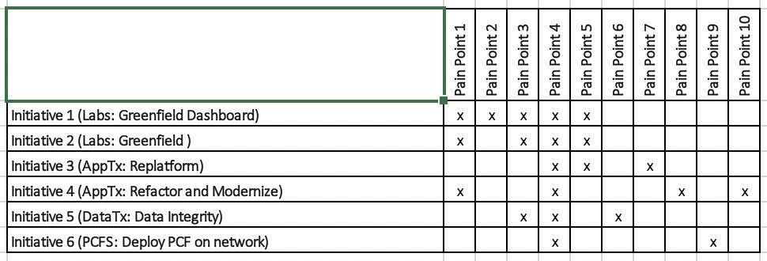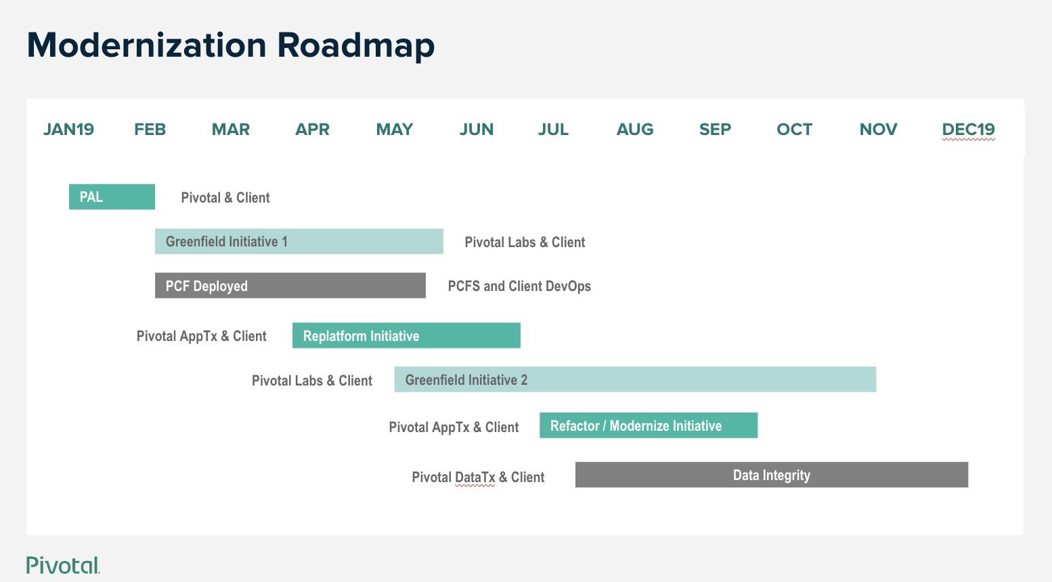

# The 4 “Re’s” of Application Transformation

**Re-Host**

*Containerize aka*

*“lift and shift”*

**Re-Platform**

*Minimal efforts to run*

*natively on PAS*

**Re-Factor**

*Convert to Cloud*

*Native aka*

*“Modernize”*

**Re-Build**

*Decompose and*

*rewrite from the*

*ground up*



**Application Portfolio**

**Funneling Process**

Business and Technical filters, prioritization, scheduling, etc.



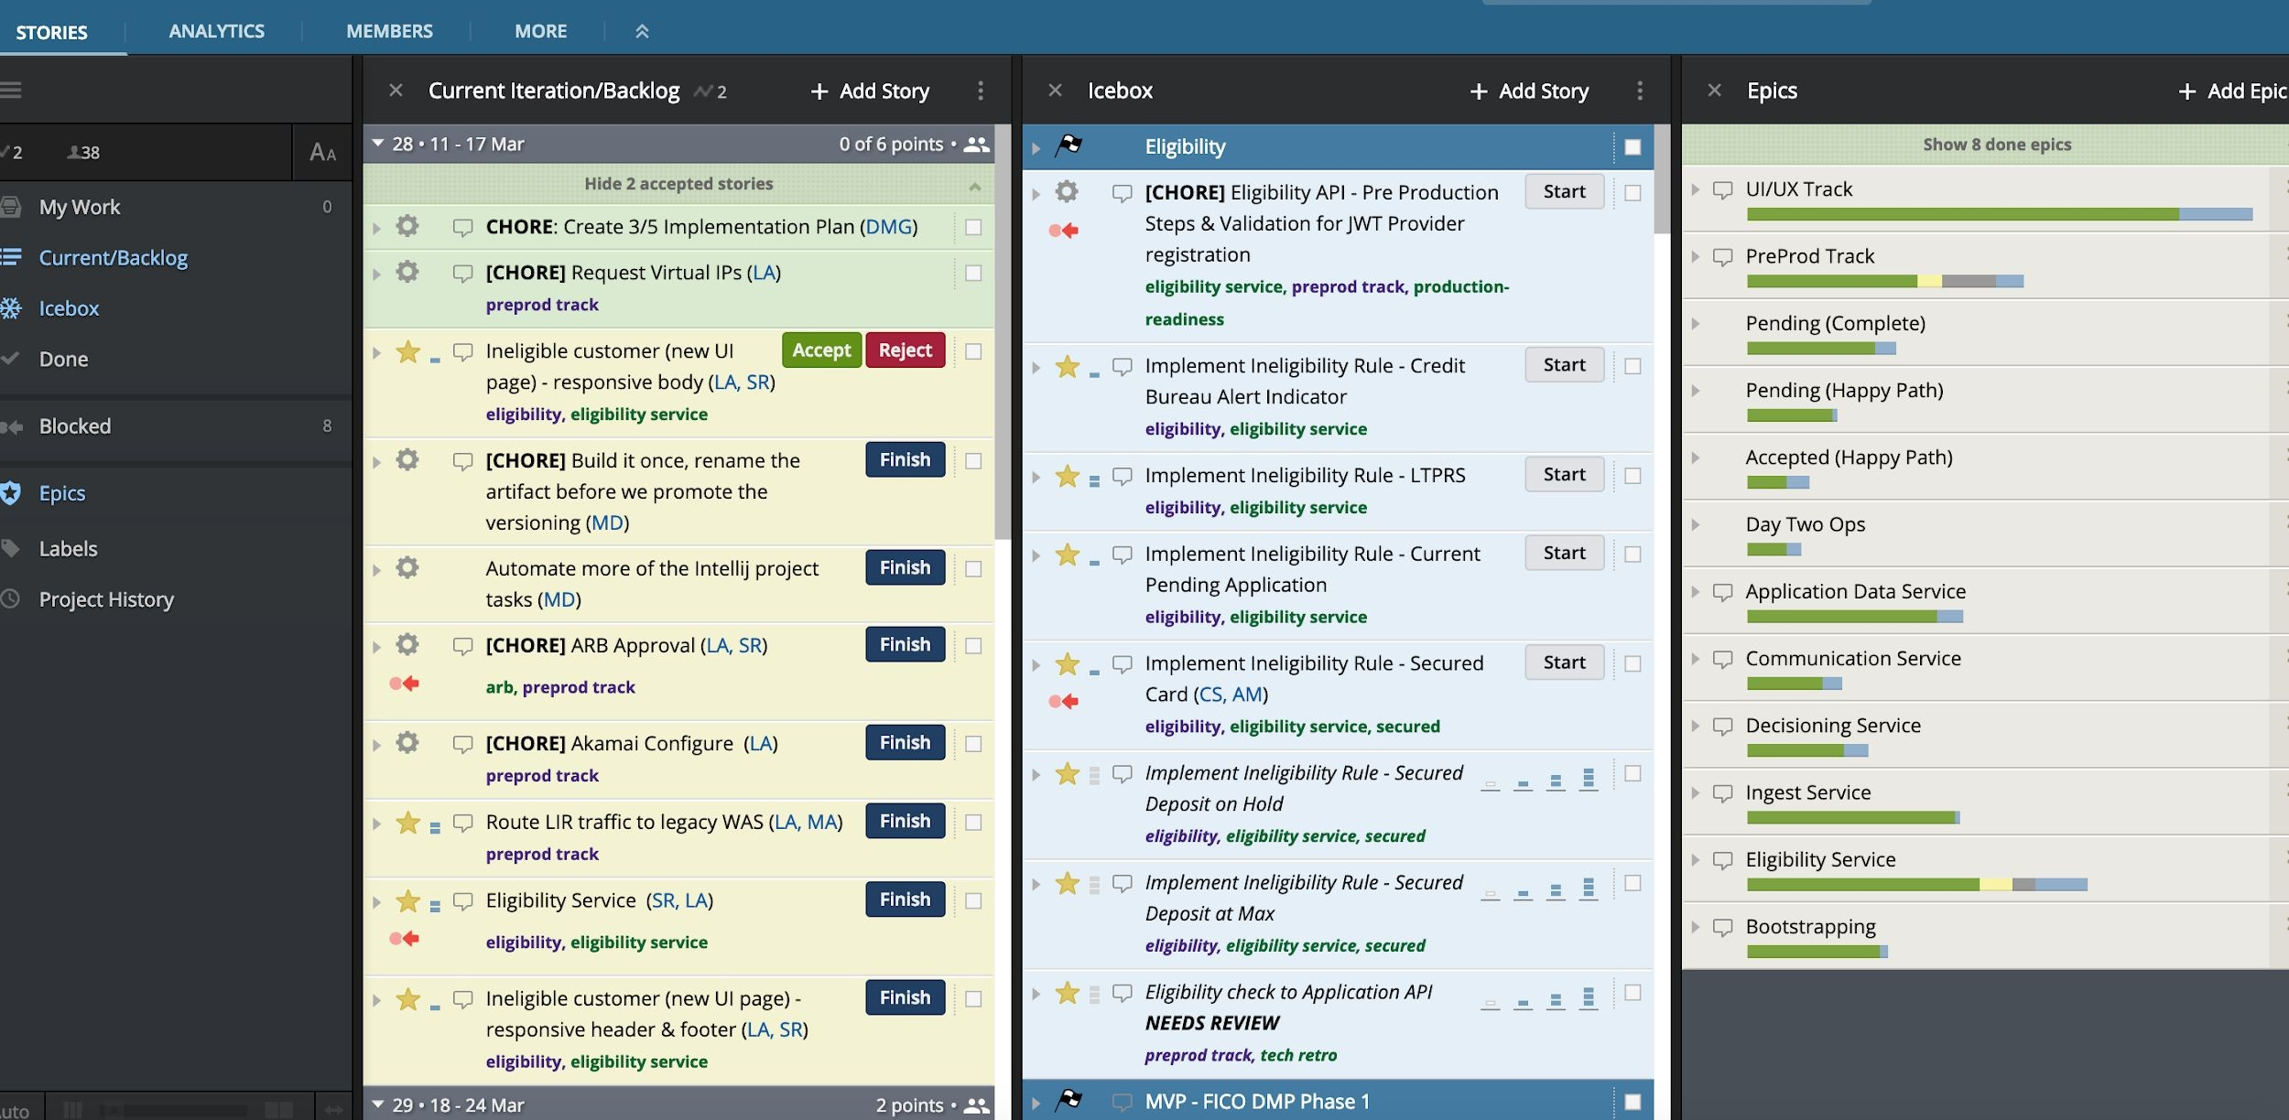

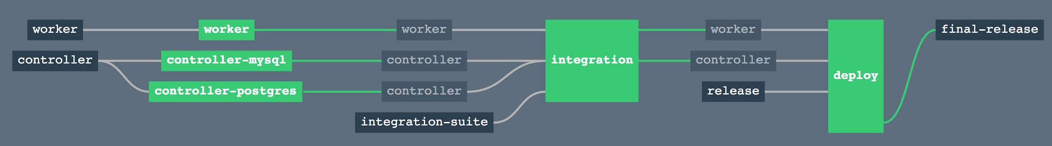

* No experience with Cloud Native

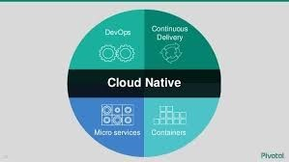

* No experience with Cloud Native
* No experience with PCF



●

No experience with Cloud Native

●

No experience with PCF

●

No experience with pairing



●

No experience with Cloud Native

●

No experience with PCF

●

No experience with pairing

●

Code not in great shape



* Pivotal doesn’t know the code



* Pivotal doesn’t know the code
* Pivotal doesn’t know the culture



●

Pivotal doesn’t know the code

●

Pivotal doesn’t know the culture

●

Pivotal doesn’t know the

business motivation



* Devs don’t own their code/design 
* 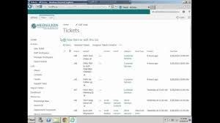Devs don’t own their code/design
* Devs don’t own their automation
* Devs don’t own their code/design



* Devs don’t own their automation
* Team does not have authority to make decisions
* Lack of executive sponsorship 
* Lack of executive sponsorship



* No full-time PO
* Lack of executive sponsorship



* No full-time PO
* Ticket completion times
* Lack of executive sponsorship
* No full-time PO



* Ticket completion times
* No SMEs

●

Lack of executive sponsorship

●

No full-time PO

●

Ticket completion times

●

No SMEs

●

External distractions



* Platform



* Platform
* Facilities/Badges/Pairing



* Platform
* Facilities/Badges/Pairing



* Platform

●

Facilities/Badges/Pairing

Code Access



●

Platform

●

●

Facilities/Badges/Pairing

●

Code Access

●

Backlog access

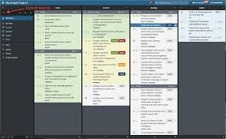

* Poor cross-org collaboration 
* Poor cross-org collaboration



* Not used to XP
* Poor cross-org collaboration



* Not used to XP
* Failure leads to scapegoating
* Poor cross-org collaboration



* Not used to XP
* Failure leads to scapegoating
* Security is an after-thought

# Summary

Some Problems Aren’t Problems

Many problems can be mitigated, but at the risk of slowing the team down due to spending time moving roadblocks instead of the code

Do The Right Thing

Do What Works Be Kind.

**Q&A**



**Links:**

* Webinar on AppTx offerings:

https://content.pivotal.io/webinars/sep-5-application-migration-how-to-start-scale-andsucceed-webinar

* Slaying the Dragon: https://www.youtube.com/watch?v=neL3OQ1GRhY&t=16s